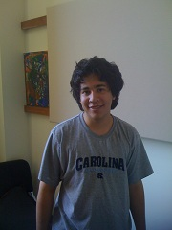

Joey Aloi

trombone

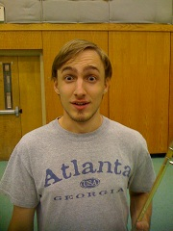

Stuart Cleaver

trombone

Pittsboro, NC

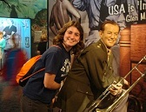

Rebecca Clemens  
Chapel Hill  
Music  
Land Rovers, listening to movie soundtracks, collecting old trombones  
[clemens2@email.unc.edu](javascript:open_compose_win('to=clemens2%40email.unc.edu&thismailbox=INBOX');)



Name- Matthew Brett Cox

Hometown- Denton, NC

Major- Music

Hobbies- Golf, Video Games

Favorite Quote- "A house divided against itself cannot stand." - Abraham

Lincoln

email- [mbcox@email.unc.edu](mailto:mbcox@email.unc.edu)

Facebook- [www.facebook.com/blowstuffup](http://www.facebook.com/blowstuffup)



Name- Ryan Dickey  
Hometown- Southlake, TX  
Major- Biology, Music  
Hobbies- Boating, Frisbee  
Favorite quote- It is unbecoming for young men to utter maxims. -[Aristotle](http://www.brainyquote.com/quotes/quotes/a/aristotle103648.html)

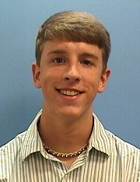

Todd Ellis

Hometown: Neenah, Wisconsin

Major: Music (BM)

Hobbies: Music, Ultimate frisbee, hanging with friends.

Quote: “I believe in Christianity as I believe that the sun has risen: not

only because I see it, but because by it I see everything else.” -C.S.

Lewis

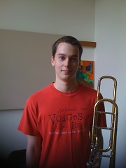

Michal Evans

trombone

Apex, NC

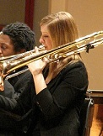

Name-  Emily Guy

Hometown-  Fuquay-Varina, NC

Major-  Music performance

Hobbies-  Trombone, Running, Coloring, Organizing

Favorite Quote-  "The point is not to take the world's opinion as a guiding star, but to go one's way in life and working unerringly, neither    depressed by failure nor seduced by applause." Gustav Mahler

Email-  [eaguy@email.unc.edu](https://webmail5.isis.unc.edu/mail/services/go.php?url=mailto%3Aeaguy%40email.unc.edu" \t "_blank)

Facebook-  [http://www.facebook.com/emilyaguy](https://webmail5.isis.unc.edu/mail/services/go.php?url=http%3A%2F%2Fwww.facebook.com%2Femilyaguy" \t "_blank)

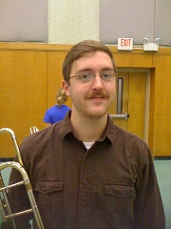

Name- Dalton C Harris  
Hometown- Cary NC  
Major- Music  
Hobbies- Alto Trombone  
Favorite quote- If the world comes to an end, I want to be in Cincinnati.  
Everything comes there ten years later.   
email- [Harrisdc@email.unc.edu](javascript:open_compose_win('to=Harrisdc%40email.unc.edu&thismailbox=INBOX');)  
Facebook-[http://www.facebook.com/profile.php?id=543295145](https://webmail5.isis.unc.edu/mail/services/go.php?url=http%3A%2F%2Fwww.facebook.com%2Fprofile.php%3Fid%3D543295145)

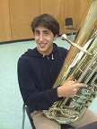

Edmond Harrison

Major: Music and Business

Hobbies: Playing/Listening to Music, Eating good food

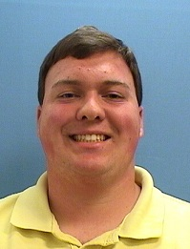

Joshua Hemric

Eastover, NC

BM in Trombone and Voice

Favorite Quote: "Music is the one incorporeal entrance into the higher world of knowledge which comprehends man kind but which mankind cannot comprehend."~Beethoven

Email: jhemric@webmail.unc.edu  or

Joshes708@aol.com

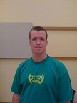

Paul Ingram

Hometown: Hope Mills, NC

Major: Bachelor's in Music w/ a concentration in Education

Hobbies: Playing video games, anything involving playing music and jamming out, and The Marching Tar Heels!

Favorite Quote: "I need you clothes, your boots, and your motorcycle." - Arnold Schwarzenegger as "The terminator"

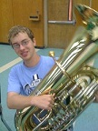

John McHenry

 Tuba

 Raleigh, NC

Hobbies: college football and basketball, pickup football,  reading, movies

 email: [johnmchenry4@gmail.com](mailto:johnmchenry4@gmail.com)

 Facebook page:  [http://www.facebook.com/home.php?#!/john.mchenry](http://www.facebook.com/home.php?#%21/john.mchenry)



Zachary Mitchell

Austin, TX

Physics (B.S.) and Music (B.A.) Double Major

Hobbies: Messing with anything technological, homework...(anything you do that much can't help but be called a hobby)

Quote: Amateurs practice until they get it right, professionals practice until they can't get it wrong.

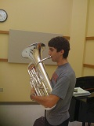

David Morgan

euphonium

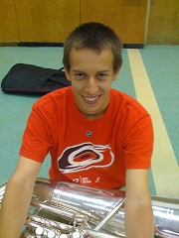

Chris Parkins

Tuba

Raleigh NC



Aaron Robinson   
Raleigh, NC   
Bachelor's of Music   
Hobbies-- trying to golf, trying to beat Mike Kris in 5K runs.   
Favorite quote: "Music has to be recognized as an agent of social development in the highest sense, because it transmits the highest values – solidarity, harmony, mutual compassion. And it has the ability to unite an entire community and to express sublime feelings." --Jose Abreu   
Email-- [aprobins@email.unc.edu](mailto:aprobins@email.unc.edu)

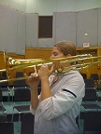

Molly Schultz

Trombone, euphonium

Charlotte, NC

[mvschultz@gmail.com](mailto:mvschultz@gmail.com)

Hobbies: music, reading, cheering for the Tar Heels, hanging out with friends

Facebook link: <http://www.facebook.com/mvschultz>

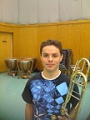

Josh Sydes

Trombone

Jacksonville, NC

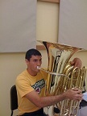

Max Wang

Tuba

Jamestown, NC

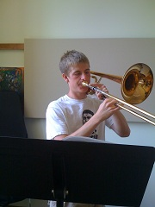

Zach Ward

Trombone